College of Computer Science and Artificial Intelligence in Wenzhou University
Web Application Development Report
Experiment: | P8: JSP (3)
Class: |  | Name: | EMETUCHE WINNER CHIDIUTO | Student ID: | 18511160023
Classroom: |  | Date:

【1. Experiment Purpose】
1.1 To understand what is JavaScript;
1.2 To learn how to add JavaScript to your HTML page;
1.3 To learn how to use functions, array and object;
1.4 To get information from drop down list;
1.5 To learn how to add check box and radio button to your pages;
【2. Experiment Condition】
2.1 Personal Computer;

【3. Content and Requirements】
3.1. Create ant song page with for array.
3.2. Create a page using array with for loop.
3.3. Create a page using object.
3.4. Create a page using drop down list.
3.5. Create a page using multiple selection.
3.6. Create a page using check box.
3.7. Create a page using radio box.
【4. Experimental Procedure】
4.1 To fill the report.
【5. Results and Analysis】

3.1. Create ant song page with for array.

<!DOCTYPE html>
<html>
<head>
<title></title>
<head>
<body>
<div style="font-size:20px; font-family: sans-serif; padding-top:30px; padding-left:30px; ">
<span style="font-weight:bold; ">Practice 7</span>
-> 3.1. Create page with for loops
</div>
<div id="-result" style="font-size:15px; font-family: sans-serif; margin-top:30px; padding-left:30px; height:60px; background:#f1f1f1; width:500px;" >
<input type="button" id="make-song" value="make song" style="width:90px; height:40px; border-radius: 5px; position: relative ; top:10px; box-shadow:0px 0px 2px 2px #ddd; border:none; font-weight: bold;">
</div>
<div id="result" style="font-size:15px; font-family: sans-serif; padding-top:30px; padding-left:30px; height:400px; overflow-y:scroll; width:500px; box-shadow:0px 0px 2px 2px #ddd;" >
</div>
</body>
<script>
var songMaker=document.getElementById("make-song");
songMaker.addEventListener("click",function(){
makeSong();
});
var displayString="";
var output;
function chorus() {
var text = "...and they all go marching down <br/>";
text += "to the ground <br/>";
text += "to get out <br/>";
text += "of the rain. <br/>";
text += " <br/>";
text += "boom boom boom boom boom boom boom boom <br /><br />";
output.innerHTML += text;
}
function verse1(){
var text = "The ants go marching 1 by 1 hurrah, hurrah <br />";
text += "The ants go marching 1 by 1 hurrah, hurrah <br />";
text += "The ants go marching 1 by 1 <br />";
text += " The little one stops to suck his thumb <br /><br />";
output.innerHTML += text;
} // end verse1
function verse2(){
var text = "The ants go marching 2 by 2 hurrah, hurrah <br />";
text += "The ants go marching 2 by 2 hurrah, hurrah <br />";
text += "The ants go marching 2 by 2 <br />";
text += " The little one stops to tie his shoe <br /><br />";
output.innerHTML += text;
} // end verse2
function makeSong(){
output = document.getElementById("result");
output.innerHTML = "";
verse1();
chorus();
verse2();
chorus();
} // end makeSong
</script>

</html>

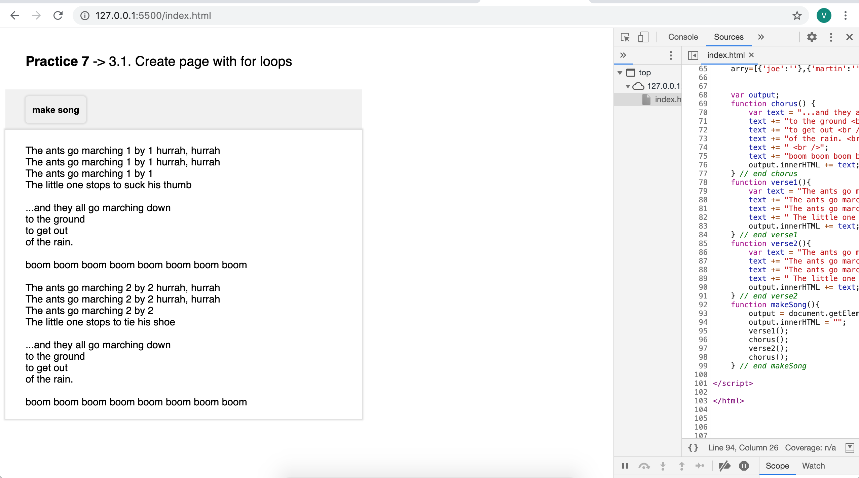

3.2. Create a page using array with for loop.

<!DOCTYPE html>
<html>
<head>
<title></title>
<head>
<body>
</body>
<script>
var displayString="";
var output;
var gameList = new Array(
"Flight Gear", "Sauerbraten", "Future Pinball",
"Racer", "TORCS", "Orbiter", "Step Mania", "NetHack",
"Marathon", "Crimson Fields");
var text = "";
for (i = 0; i < gameList.length; i++){
text += "I love " + gameList[i] + "\n";
}

alert(text);

</script>

</html>

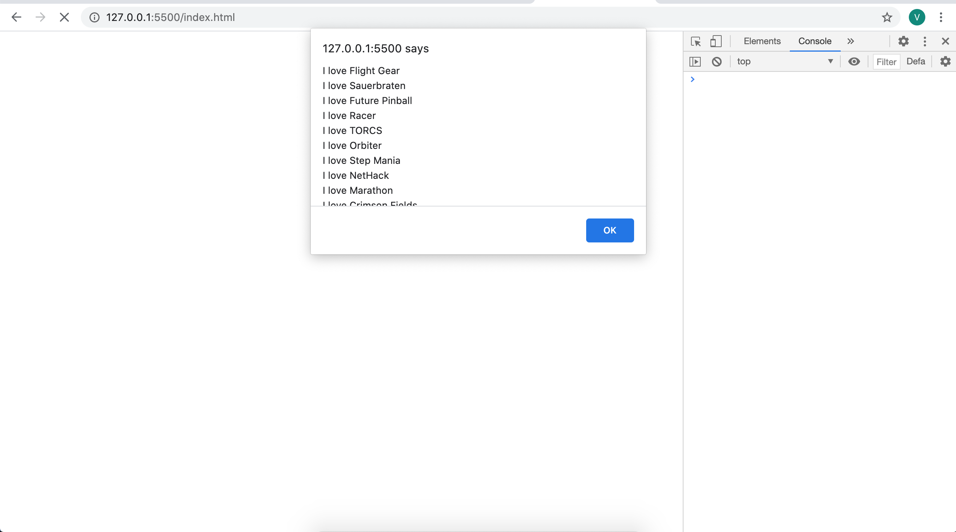

3.3. Create a page using object.
<!DOCTYPE html>
<html>
<head>
<title></title>
<head>
<body>
</body>
<script>
var critter = new Object();
critter.name = "Tom";
critter.age = 5;
alert("the critter's name is " + critter.name);

</script>

</html>
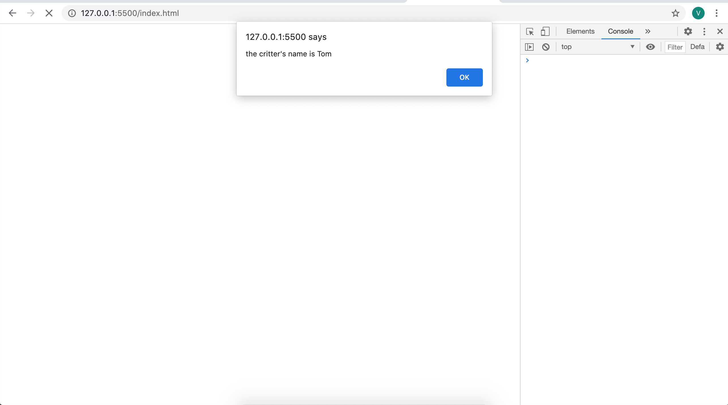

3.4. Create a page using drop down list.

<body>
<form>
<h1>Please select a color</h1>
<fieldset>
<select id = "selColor">
<option value = "#FFFFFF">White</option>
<option value = "#FF0000">Red</option>
<option value = "#FFCC00">Orange</option>
<option value = "#FFFF00">Yellow</option>
<option value = "#00FF00">Green</option>
<option value = "#0000FF">Blue</option>
247
<option value = "#663366">Indigo</option>
<option value = "#FF00FF">Violet</option>
</select>

</fieldset>
</form>
</body>

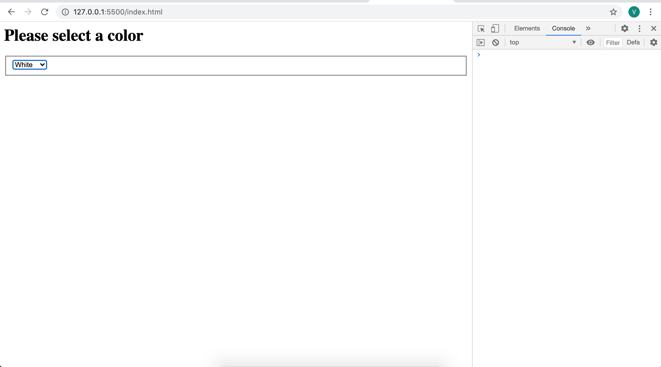

3.5. Create a page using multiple selection.
<body>
<h1>Multiple Selections</h1>
<form>
<fieldset>
<select id = "selLanguage" multiple = "multiple" size = "10">
<option value = "HTML">HTML</option>
<option value = "CSS">CSS</option>
<option value = "JavaScript">JavaScript</option>
<option value = "PHP">PHP</option>
<option value = "MySQL">MySQL</option>
<option value = "Java">Java</option>
<option value = "VB.NET">VB.NET</option>
<option value = "Python">Python</option>
<option value = "Flash">Flash</option>
<option value = "Perl">perl</option>
</select>
<button type = "button" onclick = "showChoices()"> Submit </button>
</fieldset>
</form>
<div id = "output">
</div>
</body>
<script type = "text/javascript">
function showChoices(){
var selLanguage = document.getElementById("selLanguage");
var result = "<h2>Your Languages<\/h2>";
result += "<ul> \n";
for (i = 0; i < selLanguage.length; i++){
currentOption = selLanguage[i];
if (currentOption.selected == true){
result += " <li>" + currentOption.value + "<\/li> \n";
}
}
result += "<\/ul> \n";
output = document.getElementById("output");
output.innerHTML = result;
}</script>

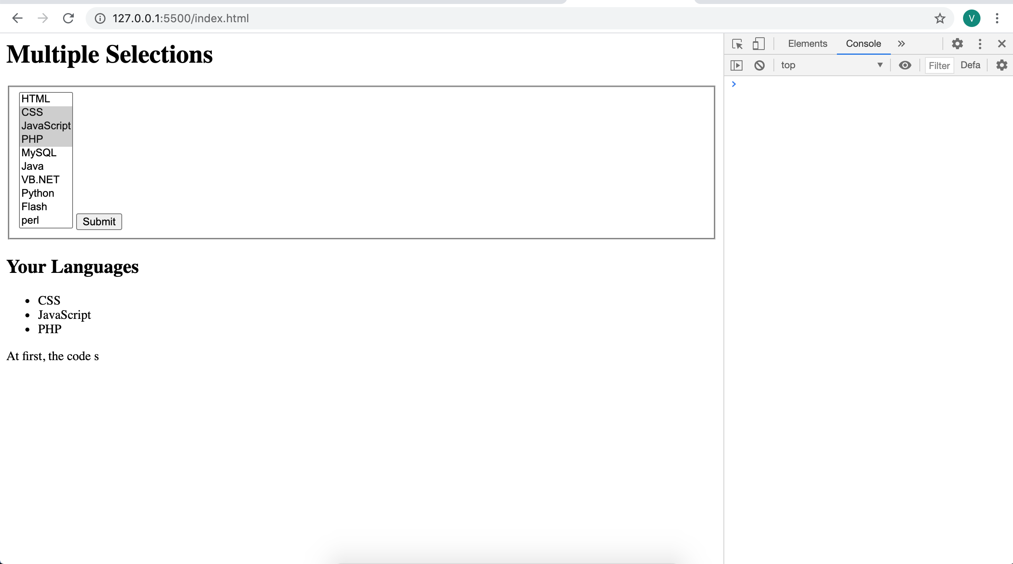

3.6. Create a page using check box.

<body>
<h1>What do you want on your pizza?</h1>
<form>
<fieldset>
<input type = "checkbox" id = "chkPepperoni" value = "pepperoni" />
<label for = "chkPepperoni">Pepperoni</label>
<input type = "checkbox" id = "chkMushroom" value = "mushrooms" />
<label for = "chkMushroom">Mushrooms</label>
<input type = "checkbox" id = "chkSausage" value = "sausage" />
<label for = "chkSausage">Sausage</label>
<button type = "button" onclick = "order()"> Order Pizza </button>
</fieldset>
</form>
<h2>Your order:</h2>
<div id = "output">
</div>
</body>
<script>
function order(){
var chkPepperoni = document.getElementById("chkPepperoni");
var chkMushroom = document.getElementById("chkMushroom");
var chkSausage = document.getElementById("chkSausage");
var output = document.getElementById("output");
var result = "<ul> \n"
if (chkPepperoni.checked){
result += "<li>" + chkPepperoni.value + "</li> \n";
}
if (chkMushroom.checked){
result += "<li>" + chkMushroom.value + "</li> \n";
}
if (chkSausage.checked){
result += "<li>" + chkSausage.value + "</li> \n";
}
result += "</ul> \n"
output.innerHTML = result;
}
</script>

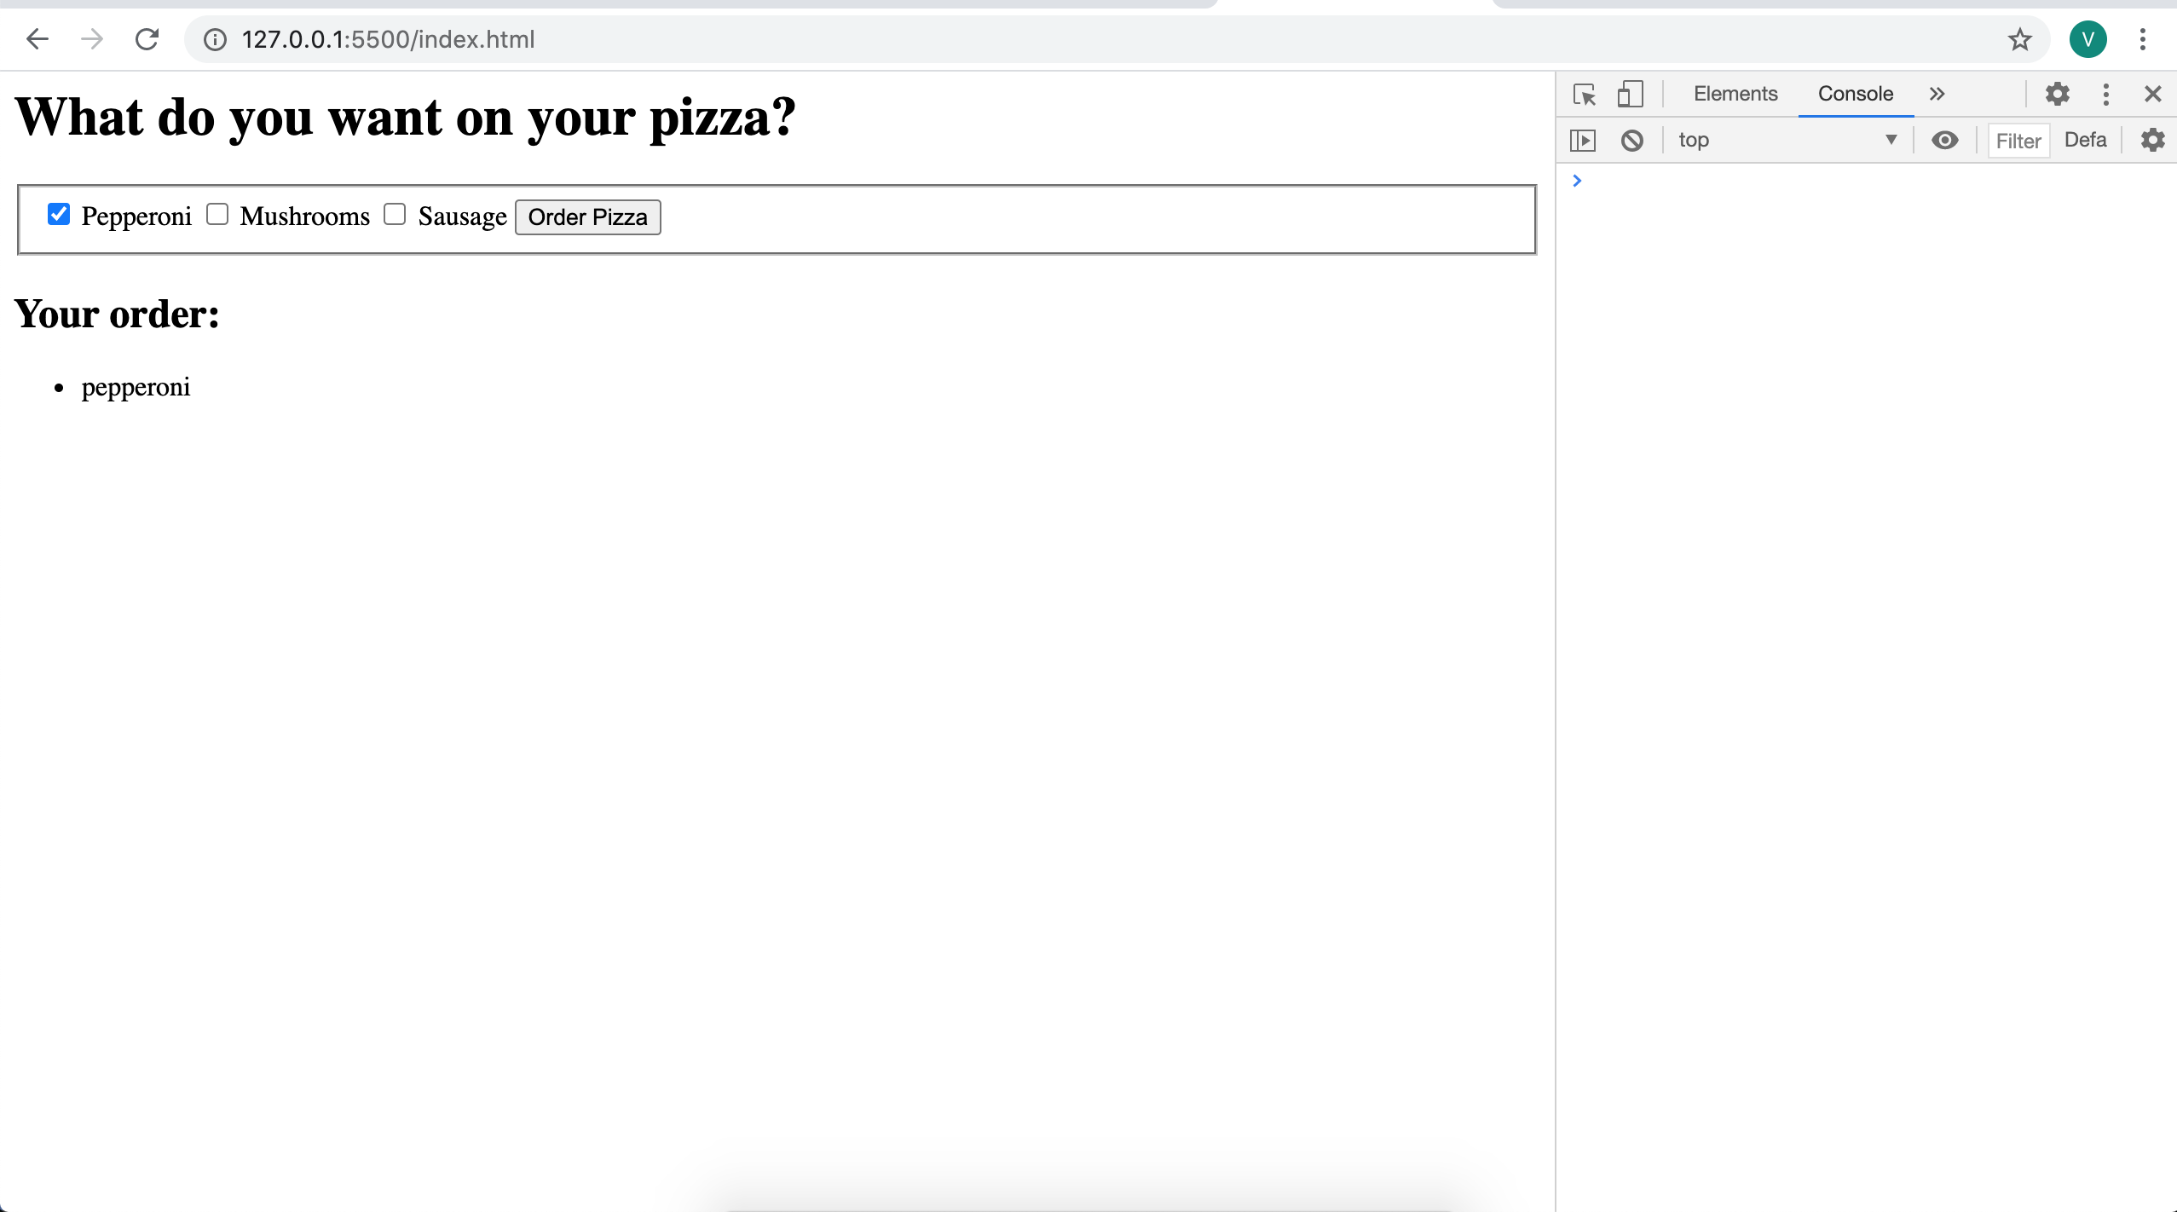

3.7. Create a page using radio box.

<body>
<h1>With what weapon will you fight the dragon?</h1>
<form action = "">
<fieldset>
<input type = "radio" name = "weapon" id = "radSpoon" value = "spoon" />
<label for = "radSpoon">Spoon</label>
<input type = "radio" name = "weapon" id = "radFlower" value = "flower" />
<label for = "radFlower">Flower</label>
<input type = "radio" name = "weapon" id = "radNoodle" value = "wet
noodle" />
<label for = "radNoodle">Wet Noodle</label>
<button type = "button" onclick = "fight()"> fight the dragon
</button>
</fieldset>
</form>
<div id = "output">
</div>
</body>

<script>
function fight(){
var weapon = document.getElementsByName("weapon");
for (i = 0; i < weapon.length; i++){
currentWeapon = weapon[i];
if (currentWeapon.checked){
var selectedWeapon = currentWeapon.value;
}
}
var output = document.getElementById("output");
var response = "<h2>You defeated the dragon with a ";
response += selectedWeapon + "</h2> \n";
output.innerHTML = response;
}
</script>

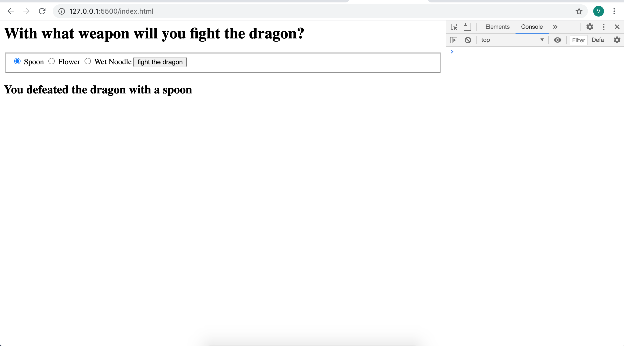

【6. Discussion】

【7. Comment】

Score: Instructor： Date:

